Electrolyte or Non-Electrolyte? That’s the question!

Draw the particulate diagram representing the molecules/ions in the solution as demonstrated by your teacher. It is not necessary to include the water molecules in the drawings of the solutions.

1. Solution: ____________________ 2. Solution: ____________________
Electrolyte – yes or no Electrolyte – yes or no
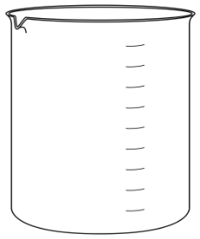

3. Solution: ____________________ 4. Solution: ____________________
Electrolyte – yes or no Electrolyte – yes or no

