Unit 8: Model Lesson 1 (student)

Data Collection
Your teacher will measure the pH of the 2 acids in the table below. Record the pH of each acid in the table. Your teacher will then place a conductivity apparatus into each solution. Record the results in the table below.

Demonstration Data

Acid | pH | Conductivity
0.10 M HC₂H₃O₂
0.10 M HCl

1. What is the pH of a 0.10 M solution of H₃O⁺ (aq)?

2. Which acid in the table above has a pH closest to the value determined in question #1?

3. Based on the measured pH of the acid identified in #2, to what degree did this acid dissociate?

4. Write the dissociation equation for the acid identified in question #2.

5. Does the pH of the other acid indicate that it dissociates to the same degree? Explain.

Particle Diagrams

Consider your responses to the questions above as you complete this section. In the boxes provided, draw the particle diagram for each of the acids as they would appear in water. Use the key provided to represent the particles. Water molecules would be present; however, for the sake of simplicity, omit the water molecules.

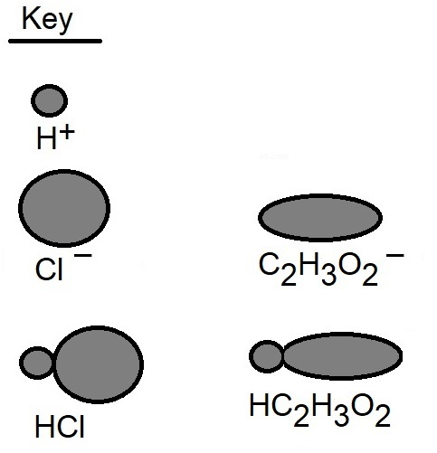

0.10 M HC₂H₃O₂

0.10 M HCl

A strong acid is an acid that dissociates completely in an aqueous solution. Conversely, a weak acid is an acid that does not completely dissociate in an aqueous solution – rather it partially dissociates.

1. Based on all previous data and diagrams, identify which of the 2 acids is a strong acid and which is a weak acid. Explain.

2. Now that you have identified the weak acid and the strong acid, explain how the conductivity data in the demonstration table supports your choices.

Conjugate Acids & Bases

Your teacher will describe the concept of conjugate acid-base pairs.

1. Based on the particle diagram drawn for acetic acid, write the dissociation equation for this acid in aqueous solution.

2. Identify the conjugate acid-base pairs in the above dissociation equation.

3. Write the dissociation equation for the weak acid HOCl in aqueous solution. Identify the conjugate acid-base pairs in this equation.

Acid Dissociation Constant
Your teacher will introduce the concept of acid dissociation constant, K_{a}.

1. Write the K_{a} expression for acetic acid.

2. Write the K_{a} expression for hypochlorous acid, HOCl.

3. The K_{a} value for acetic acid is 1.8 x 10⁻⁵, and the K_{a} value for hypochlorous acid is 3.5 x 10⁻⁸. Which acid is the stronger acid? Explain using the K_{a} values.

Calculation of pH of a Weak Acid Using ICE Tables

Because weak acids involve the partial dissociation of the acid in aqueous solution, pH is calculated using the K_{a} and an ICE table. Your teacher will demonstrate how to use an ICE table and K_{a} to determine the concentration of H₃O⁺ so as to determine the pH of the 0.10 M aqueous solution of acetic acid. Percent ionization of a weak acid will be demonstrated also.

 | HC₂H₃O₂ | H₃O⁺ | C₂H₃O₂⁻
I
C
E

K_{a} and calculation of pH:

Percent dissociation:

1. How does the calculated pH of 0.10 M aqueous acetic acid solution compare to the measured pH? Explain any discrepancy.

2. Perform the same calculation of pH for a 0.10 M aqueous solution of hypochlorous acid.

 | HOCl | H₃O⁺ | OCl⁻
I
C
E

K_{a} and calculation of pH:

Percent ionization:

3. Do the calculated pH values and percent ionizations of 0.10 M aqueous solutions of acetic acid and hypochlorous acid support your choice of which acid is the stronger acid? Why or why not?

