AP Chemistry
Lab: Determination of the Molar Mass of Butane

Introduction
The molar masses of compounds are used daily in the chemistry profession. The molar mass is defined as the mass, in grams, of 1 mole of any element or compound. How is molar mass determined and how is the molar mass of an unknown found? In this experiment, the molar mass of butane, C₄H₁₀ (a gas at room temperature), will be calculated based on physical measurements of mass, volume, temperature, and pressure. These measurements will be entered into an equation to calculate the molar mass of the gas butane.

Concepts
- Molar Mass - Ideal Gas Law

Background
The ideal gas law relates the four measurable properties of a gas, (P, V, n, T). In this experiment, the ideal gas law will be used to determine the molar mass of butane gas.
(given on exam)

PV = nRT Equation 1

The number of moles (n) of any pure substance is equal to its mass (m) divided by its molar mass (M).
n = m (mass) Equation 2
(given on exam)

M (molar mass)

Substituting for n in Equation 1 and then rearranging produces the equation for the molar mass (M) of a gas.
M = m x RT
P x V

Equation 3
(NOT given on exam)

R = 0.08206 L·atm
mol·K

A sample of butane gas, C₄H₁₀, is obtained from a disposable lighter. The lighter is weighed both before and after the gas is withdrawn from it to determine the mass of gas withdrawn. The volume, temperature, and pressure are also measured. From these four quantities, the molar mass of the gas is calculated. Since the gas is collected over water, a correction is made for the pressure measurement caused by the water vapor in the sample of collected gas. The molar mass of the gas is then determined from Equation 3 using the mass of gas, the volume of gas, the atmospheric pressure, and the room temperature.
The gas is treated as an ideal gas, i.e. it is assumed the molecules have no intermolecular attractions which could affect the results, and have a negligible volume compared to total volume.

Experiment Overview
The purpose of this experiment is to determine the molar mass of a butane gas. The gas is released from a lighter and massed by calculating the lighter’s change in mass. The volume is determined by matching the water level inside a graduated cylinder to the water level outside the cylinder at the 100.0 mL mark. The temperature is taken from the water, and the pressure is taken as the atmospheric pressure in the room corrected by subtracting the vapor pressure of water at the room’s temperature. The molar mass of the gas is then calculated from the experimental data using an algebraically rearranged equation from the ideal gas law.
Materials
Chemicals
Butane, CH₃CH₂CH₂CH₃ (or C₄H₁₀)

Equipment
pneumatic trough (covered drain hole) balance, centigram precision (0.01-g)
barometer (room air pressure) graduated cylinder, 100-mL
thermometer (room temperature) disposable butane lighter
paper towel (2)

Safety Precautions
Butane is a flammable liquid and a fire risk.

Procedure
- Obtain a metal pneumatic trough and FIRST cover the drain hole with tape. Fill the trough up to the bottom of the covered drain hole (about from the top)

- You may or may not want to remove the metal safety device on your lighter before proceeding. Immerse the lighter in the water trough and remove it. Dry the lighter thoroughly with a paper towel. Weigh the lighter and record the mass in the Data Table.

- Fill the 100-mL graduated cylinder completely full with tap water by submerging it in the trough without trapping any air in the top of the cylinder.

- Hold the lighter under the water, making sure that the gas opening is beneath the mouth of the cylinder. Lift the mouth of the cylinder slightly while keeping it under the water at all times. While holding the cylinder vertically, press the release lever of the lighter ensuring that all of the gas bubbles enter the cylinder.

Displace about 90 mL of water from the graduated cylinder. To collect the last 10 mL of butane, adjust the height of the graduated cylinder so that the 100-mL mark lines up with the level of water in the trough. Hold the cylinder vertically and fill it to the 100-mL mark with butane. (This ensures that the pressure of gas inside the cylinder will be the same as the atmospheric pressure that you will record, and that your volume is known to be 100.0 mL)
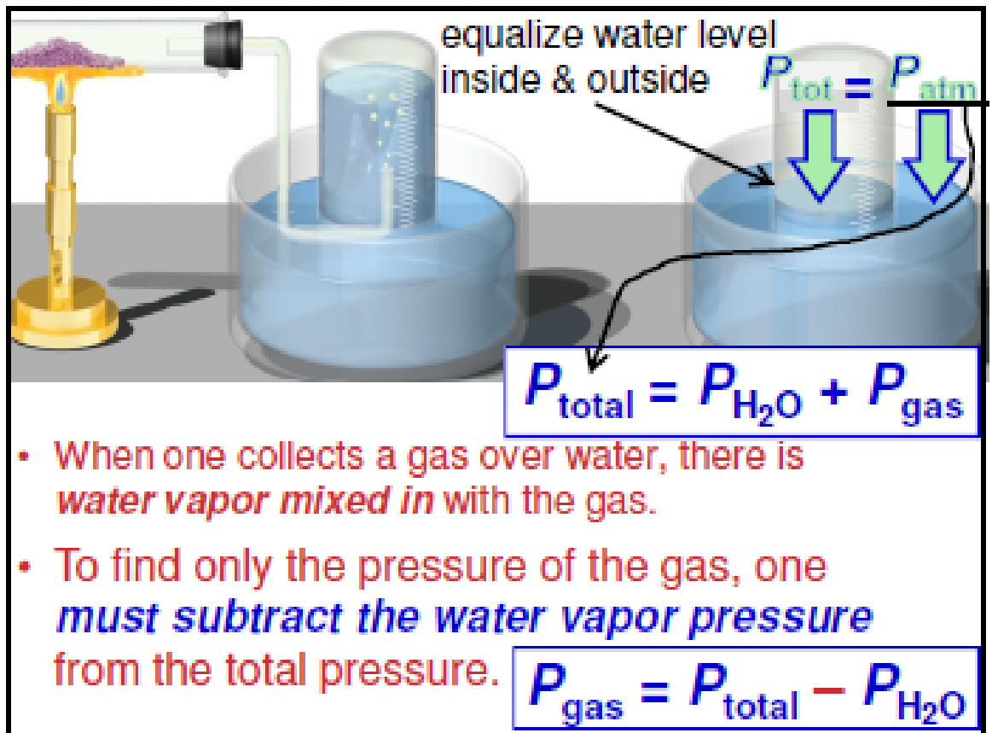

- Remove the lighter and shake off any excess water. Dry it thoroughly in exactly the same manner as you did previously in Step 2. Re-weigh the lighter and record this mass in the Data Table.
Determine the mass of butane gas used in the experiment.

- Remove the graduated cylinder from the water and release the butane gas in the fume hood.

- Measure the temperature of the water in the trough and record this in the Data Table as the temperature of the butane gas.

- Obtain the atmospheric pressure of the room and record it in the Data Table.

Data Table

Mass of lighter before experiment | g
Mass of lighter after experiment | g
Mass of butane gas used | g  m
Volume of butane gas collected | V  100.0 mL
Temperature of butane gas | ºC  T
Atmospheric pressure | torr
Vapor pressure of water | torr  (see chart below)
(corrected) Pressure of butane gas | torr  (see calc. #1 below)  P

Vapor Pressure of Water at Various Temperatures:
Temp Press

Temp Press

Temp Press

°C | torr | °C | torr | °C | torr
16 | 13.6 | 21 | 18.6 | 26 | 25.2
17 | 14.5 | 22 | 19.8 | 27 | 26.7
18 | 15.5 | 23 | 21.0 | 28 | 28.3
19 | 16.5 | 24 | 22.4 | 30 | 31.8
20 | 17.5 | 25 | 23.7 | 30 | 31.8

Data Analysis and Calculations

- Determine the partial pressure of the butane gas. The gas in the flask is not all from the butane lighter since there is also water vapor present. According to Dalton’s Law of Partial Pressures, the total pressure in the flask is the sum of the vapor pressure of the water and the pressure of the butane. (see the image after procedure step #4)
Determine the pressure of the butane gas. (show work)(record your answer in the Data Table)

- Use PV = nRT to calculate the number of moles of butane gas that were collected in the flask. When using this formula ensure that all measurements (P, V, R & T) pertain to the butane gas.

- Knowing the mass of butane collected, calculate the molar mass (g/mol) of butane.

- Using substitution, show how Equations 1 & 2 combine to make Equation 3 on the first page. Then, re-calculate the molar mass (g/mol) of butane using Equation 3.

- Calculate the actual molar mass of butane (C₄H₁₀) and then calculate the percent error for your experiment.
difference between experimental and true value
as a percentage of the true value

- Write your exp. Value of molar mass on the board. Calculate the average molar mass of butane (C₄H₁₀) for the entire class and then calculate the percent error for the class.

Post-Lab Questions

- How do you explain the fact that butane is a liquid in the lighter, but is a gas when it is released and collected?

- Why did you have to consider the water vapor pressure?

- Consider the water level inside the graduated cylinder. Suppose that when adjusting measuring this water level, the student actually (but unknowingly) allowed the water level inside the flask to remain a little higher than the outside water level, but still recorded the gas pressure as the value of atmospheric pressure in the data table. (just like a test question)

- How would this affect your recorded measurement for the pressure of butane gas?

- Describe how this error would affect your calculation of the molar mass of butane gas? (higher, lower, no change)

- When drying the lighter for weighing after releasing the butane, the student incompletely dried the lighter leaving more excess water on it than during its previous weighing.

- How would this affect your recorded measurement for the mass of butane gas?

- Describe how this error would affect your calculation of the molar mass of butane gas? (higher, lower, no change)

- Determine the molar volume of your gas by dividing liters of butane gas by moles of butane gas using these values from your experiment.

The molar volume of any gas at standard temperature and pressure (STP: 273 K & 1 atm) is 22.4 L. mol^{–1}. Is your calculated value higher or lower than this standard value? Explain the difference by considering the temperature and pressure of the room the butane gas was measured in (hint: consider STP).

