Physical Science
Wkst - Review I for Chapter 2 Motion

_____ 1. A measure of the path taken by an object is known as its _______
A. motion C. displacement
B. velocity D. distance

_____2. The distance and direction of the object’s change in position is known as its ________
A. motion C. displacement
B. velocity D. distance

3. You get out of your desk, walk 20 m, take a book from a table, walk back to your seat and sit down.
a) What is the distance you traveled?

b) What is your displacement?

I CAN Explain the difference between speed and velocity

_____ 4. The distance an object travels per unit of time is known as its __________
A. speed C. displacement
B. velocity D. distance

_____ 5. The speed of an object and the direction of its motion is known as its __________
A. speed C. displacement
B. velocity D. distance

_____ 6. The speed you read on a speedometer is an example of ___________
A. instantaneous speed C. average speed
B. constant speed D. velocity

7. A dog runs 2 km in 0.4 hr. Calculate the dog’s speed.

8. A car is moving with a constant speed of 15.0 m/s along a straight path. What is the distance covered by the car in 720 sec?

9. You travel 190 km in 2 h. What is your speed in km/s?

10. Explain the difference between speed and velocity.

I CAN Interpret motion graphs
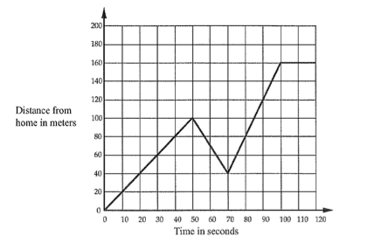
11. Explain the motion between 0-50 sec *use specific speed(s) (show your work)

12. Explain the motion between 70-120 sec *use specific speed(s) (show your work)

13. What is the average speed over 110 seconds?
I CAN Describe how acceleration, time, and velocity are related

_____14. Acceleration is the rate of change of _________.
A. position C. velocity
B. time D. force

_____15. To describe the velocity of an object, you need to know _________________.
A. speed and direction C. direction and acceleration
B. speed and time D. speed and acceleration

I CAN Explain how positive and negative acceleration affect motion

Speed
Time

_____16. A horizontal line on the acceleration graph above shows ______________ acceleration.
A. positive C. changing
B. negative D. zero

I CAN Calculate the acceleration of an object
17. Find the acceleration of a car that goes from 32 m/s to 96 m/s in 8 s.

18. An ostrich accelerates at 8 m/s² to a speed of 40 m/s. If the ostrich was already running with a speed of 5 m/s, how long did it take to accelerate to its final speed?

