Physics Chapter 4

Wkst: Drawing Force Diagrams 2

In each of the following situations, represent the object with a box. Draw and label all the forces using standard force symbols as learned in class.

1. Object lies motionless on a surface. | 2. Object slides at constant speed along a Smooth (frictionless) surface.  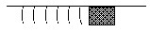
3. Object slows due to friction (rough surface).  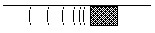 | 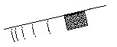  4. Object slides on a smooth incline.
5. Friction on an incline prevents sliding. | 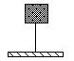  6. An object is suspended from the ceiling.
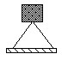  7. An object is suspended from the ceiling. | 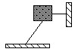  8. The object is motionless.
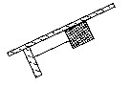  9. The object is motionless. | 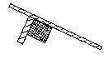  10. The object is motionless.

Worksheet, Drawing Force Diagrams 1 9/23/2009

11. The object is pulled by a force parallel to the surface. The surface is rough or has friction. | 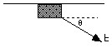  12. The object is pulled by a force at an angle to the surface. The surface is rough.
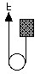
13. The object is pulled upward at constant speed.

14. The object is falling (no air resistance). | 15. The object is falling at constant (terminal) velocity.
16. The ball is rising in a parabolic trajectory.  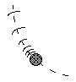  Do not neglect air resistance | 17. A rocket is accelerating straight upward.
18. A skier is accelerating down a slope. There is friction and air resistance.  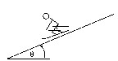 | 19.A big block of mass M is attached via a string to a smaller block of mass m. A student attaches a string to block M and pulls everything to the right along the rough surface. Both blocks travel at constant velocity.  Do force diagrams for each block separately.

