Things You Just Have to Memorize

There are some things that you MUST memorize in AP Chemistry. Here is a starting list.

Element Names & Symbols
The periodic table you get has symbols & #’s, but no names
- Know the name & symbol for the 1st 38 elements AND Ag, Cd, Sn, I, Xe, Cs, Ba, Pt, Au, Hg, Pb, Bi, Rn, U

Polyatomic Ions
Know name, formula, and charge

Positive Ions (Cations)
1+ | 2+ | 3+
- Ammonium (NH₄⁺)  - Silver (Ag⁺)  - Hydronium (H₃O⁺) | - Cadmium (Cd²⁺)  - Zinc (Zn²⁺) | - Aluminum (Al³⁺)

Negative Ions (Anions)
1- | 2- | 3-
- Acetate (C₂H₃O₂⁻)  - Chlorate (ClO₃⁻)  - Chlorite (ClO₂⁻)  - Cyanide (CN⁻)  - Hydride (H⁻)  - Hydrogen carbonate or bicarbonate (HCO₃⁻)  - Hydrogen sulfite or bisulfite (HSO₃⁻)  - Hydroxide (OH⁻)  - Nitrate (NO₃⁻)  - Nitrite (NO₂⁻)  - Perchlorate (ClO₄⁻)  - Permanganate (MnO₄⁻)  - Thiocyanate (SCN⁻) | Carbonate (CO₃²⁻)  Chromate (CrO₄²⁻)  Dichromate (Cr₂O₇²⁻)  Peroxide (O₂²⁻)  Sulfate (SO₄²⁻)  Sulfite (SO₃²⁻)  Oxalate (C₂O₄²⁻) | Phosphate (PO₄³⁻)  Phosphite (PO₃³⁻)

Solubility Rules:
All sodium, potassium, ammonium, and nitrate salts are soluble in water.

Periodic Table Patterns
- Groups: noble gases, halogens, alkaline metals, alkaline earth metals, transition metals
- Trends: atomic radius, ionic radius, ionization energy, electronegativity

The 7 Diatomic Elements
- These are diatomic when they are alone as a neutral element (not in a compound, not as an ion)
- Remember: Start at #7 and make a 7
  - Hydrogen (H₂); Nitrogen (N₂); Oxygen (O₂); Fluorine (F₂); Chlorine (Cl₂); Bromine (Br₂); Iodine (I₂)

Metric Prefixes
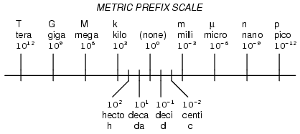

Rules for Assigning Oxidation States
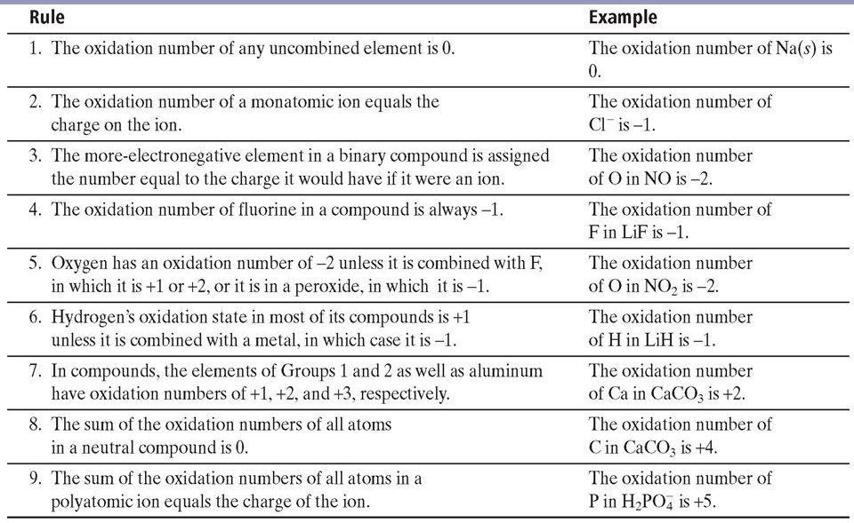

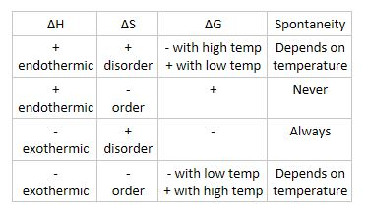
Thermodynamic quantities

Molecular Geometry: shapes & bond angles
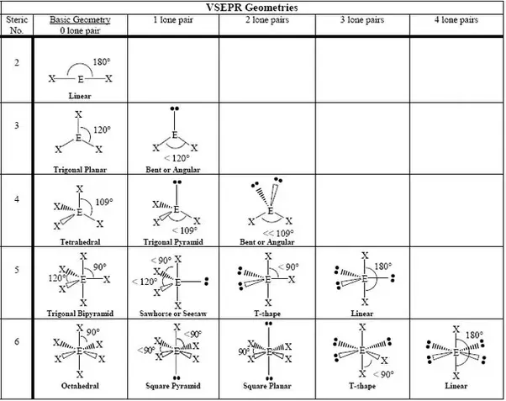

Straight line plots
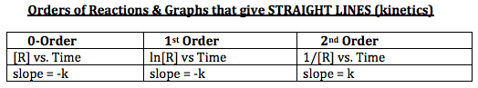

Strong Acids and Bases

The 7 Strong Acids  •HNO₃ nitric acid  •H₂SO₄ sulfuric acid  •HBr hydrobromic acid  •HI hydroiodic acid  •HCl hydrochloric acid  •HClO₃ chloric acid  •HClO₄ perchloric acid | The 8 Strong Bases  •LiOH lithium hydroxide  •NaOH sodium hydroxide  •KOH potassium hydroxide  •RbOH rubidium hydroxide  •CsOH cesium hydroxide  •Ca(OH)₂ calcium hydroxide  •Sr(OH)₂ strontium hydroxide  •Ba(OH)₂ barium hydroxide

