Ch 13 Gas Laws: Investigation Lab

Complete each of the three stations around the room. Do our regular lab note book set up. One lab book per group. Answers each question with a stand alone sentence!

Objectives
By the end of this lesson, you should be able to:
- Understand the relationship between temperature and volume of a gas at constant pressure.
- Understand the relationship between temperature and pressure of a gas at constant volume.
- Understand the relationship between pressure and volume of a gas at constant temperature.

Prelab questions:

- For Charles, Boyles, and Gay-Lussac's gas laws state the constant and variables for each equation.

- Think of an example of each gas law in real world situations. Example: the air pressure of your car tires in winter vs. summer. State what are the variables and constant with each example.

Lab 1: Chillin’ and Heatin’

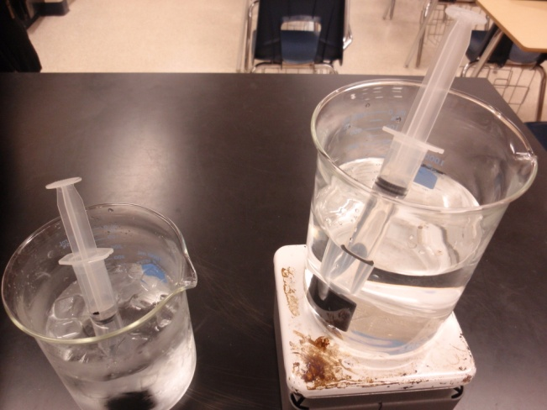
Procedure:

- Put the sealed syringe in the ice water bath
- Leave the syringe in for a couple of minutes
- Record the temperature of the ice bath
- Record the volume of air in the syringe
- Put the syringe into a warm water bath
- Leave the syringe in for a couple of minutes
- Record the temperature of the water bath
- Record the volume of air in the syringe
- Explain what happened to the air particles on your lab sheet
Lab 1 Questions
- What did you observe? (Include what you see and quantitative data.)
- Graph your results.
- Draw how the air particles look in the syringe before and after the change. Also draw the macroscopic change.
- What are your variables? Constant?
- What gas law did this lab demonstrate.
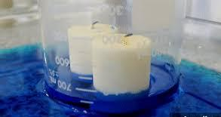
Lab2: The Candle and beaker

Procedure:

- Light the candle.
- Place the beaker mouth down over the candle
- Observe what happens
Lab 2 Questions
- What did you observe? Include a before and after diagram.
- What effect did the water have on the gas inside the flask? How do you know?

Many people mistakenly believe that the water rises into the flask because the candle is removing oxygen from the air. This explanation is not correct because the candle replaces oxygen with carbon dioxide. The conservation of mass tells us that the mass after the chemical reaction is the same as before because no atoms can be created or destroyed. In this case, the oxygen became the products, CO2 + H2O, and wasn’t destroyed.

- What is the actual explanation for why the water rose up into the flask? Use terms like cool, volume, and pressure in your explanation.
- What are your variables? Constant?
- What gas law did this lab demonstrate.

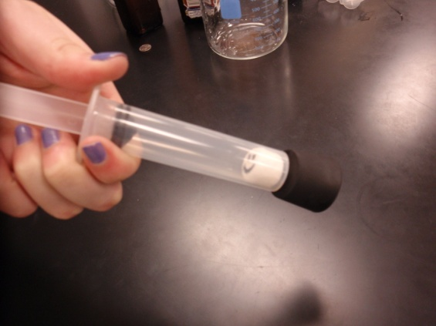
Lab 3: The Distortion of Marshmallows
Procedure:
- Draw a face on a marshmallow
- Remove the plunger and put the marshmallow inside the syringe
- With the end open, replace the plunger and slowly push it so it barely touches the marshmallow
- Cover the opening with your finger and slowly pull the plunger
- Record observations on your lab sheet
- Let the plunger move back down and record observations on your lab sheet (what is “pushing” the plunger?)
- Explain what you think is happening on your lab sheet
Lab 3 Questions
- Draw how the air particles look in the syringe before and after the change. Also draw the macroscopic change.
- What are your variables? Constant?
- What gas law did this lab demonstrate?

Teacher Notes
- You could return to the (optional) data collected in the Chillin’ and Heatin’ (station 1) to have students verify Charles Law. You could have them also take measurements at room temperature and then graph T vs. V, T vs. 1/V, and T vs. V² to find the linear relationship.
- In “Chillin’ and Heatin’,” students work with a sealed, variable volume syringe at two temperatures. For the purposes of this investigation, the actual temperatures are not important; they need to recognize only that one temperature is higher than the other. They should note that as temperature increases, the volume of the gas also increases, because the average velocities of the air molecules increase. Students need to understand that the pressure didn’t change, it is room pressure. They also need to know that the amount of air inside was constant.
- In “Distortion of Marshmallows,” students discover that as they increase the volume of a sealed syringe, air molecules in the marshmallow inside the syringe are able to occupy a larger volume. The total volume of air in the syringe, and the internal marshmallow, increases as pressure goes down. This cycle of expansion is followed by a compression, during which the marshmallow shrinks because the air molecules are confined to a smaller space at higher pressure. (Ultimately the marshmallow fails because of the attraction of the molecules of the marshmallow for each other and the irreversible escape of the last of the gas inside the marshmallow.)

