Introduction to Equilibrium

The purpose of this activity is to let students create a system at equilibrium in order to develop their own definition of this term.

Materials at your station:
2- straws (different diameters) 2- 25 mL graduated cylinders Water

Round 1:
- What do you think equilibrium means?

- In this activity you will be transferring water with different size straws from one graduated cylinder to another. How do you think you will know that you have reached equilibrium?

Procedure:
- Put 25 mL of water in graduated cylinder A. Record the initial amount of water. Leave graduated cylinder B empty and record this in your data table. (If possible, put your data in a graphing program like excel or goggle sheets. Doing so will let you see a graph being plotted at the same time you enter your data which allows for more interesting conclusions being drawn. See your teacher for more instructions)
- Put straw A in graduated cylinder A and straw B in graduated cylinder B until they touch the bottom of the cylinder. Place your finger over the top of the straw to capture water in the straw.
- Transfer the water in straw A into graduated cylinder B, at the same time transfer water in straw B into graduated cylinder A. Record the new volumes in each graduated cylinder on the provided data table.
- Repeat steps 2 and 3 until you get five readings with no change in volume. Equilibrium has been established.

Discuss the following questions:
- What happened to the amount in graduated cylinder A? graduated cylinder B?
- Was the amount of water in graduated cylinder A equal to graduated cylinder B?
If not, what was equal when you reached equilibrium?
- Write a new definition of equilibrium based on what you just learned. (Your teacher will at this point may ask you and your group to share your definition)

Data Table:
Transfers | A (mL) | B (mL) |  | Transfers | A (mL) | B (mL)
0 |  |  |  | 13
1 |  |  |  | 14
2 |  |  |  | 15
3 |  |  |  | 16
4 |  |  |  | 17
5 |  |  |  | 18
6 |  |  |  | 19
7 |  |  |  | 20
8 |  |  |  | 21
9 |  |  |  | 22
10 |  |  |  | 23
11 |  |  |  | 24
12 |  |  |  | 25

Graph: Graph both the volume of A compared to number of transfers and the volume of B compared to number of transfers. Include a legend (key) to distinguish between the graph for A and the graph for B.

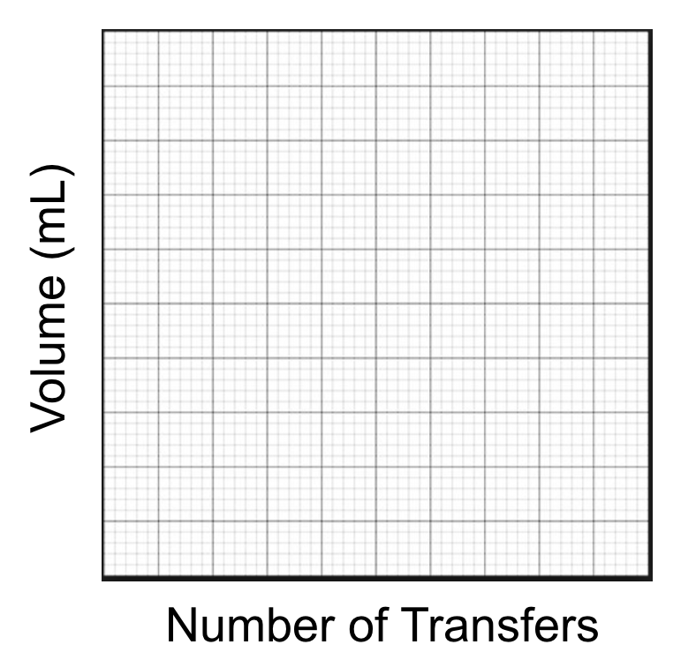

- Assuming that this lab simulates the reaction: A (reactants) ⇌ B (products)
What do the following represent?
- The volume of water in A _____________________________
- The volume of water in B _____________________________
- Transferring the water from A to B _____________________________
- Transferring the water from B to A _____________________________
- Number of transfers _____________________________
- Look at your graph.
  - Describe what happened to the amount of A initially? _____________________
  - Describe what happened to the amount of B initially? _____________________
  - Eventually what happened to the amount of A and B? ________________
    - What does this represent? _____________________
- When your system was at equilibrium was the amount of A and B equal? ____________
- What was equal when your system was at equilibrium? _____________________

Post Lab: AP Extension Questions
_____1) Cr₂O₇²⁻(aq) + 3H₂O (l) ⇄ 2CrO₄⁻²(aq) + 2H₃O⁺(aq)
orange yellow
The equilibrium system represented by the equation above initially contains equal concentrations of Cr₂O₇²⁻(aq) and 2CrO₄²⁻ (aq). Which of the following statements correctly predicts the result of adding a sample of 6.0M NaOH (aq) to the system and provide an explanation.

(A) The mixture will become more orange because OH⁻ (aq) will oxidize the Cr in the CrO₄²⁻ (aq) (B) The mixture will become more yellow because OH⁻(aq) will reduce the Cr in the Cr₂O₇²⁻(aq).
(C) The mixture will become more yellow because OH⁻(aq) will shift the equilibrium towards the products.
(D) The color of the mixture will not change because the OH⁻(aq) doesn’t show up in the equilibrium expression.

_____2)
Reaction A: 4HCl (g) + O₂ (g) ⇄ 2Cl₂ (g) + 2H₂O(g)
Reaction B: N₂O₄ (g) ⇄ 2NO₂ (g)
Reaction C: H₂ (g) + I₂(g) ⇄ 2HI(g)
Reaction D: 2NH₃(g) ⇄ N₂(g) +3H₂ (g)
The reactions represented above are carried out in sealed rigid containers and allowed to reach equilibrium. If the volume of each container is reduced from 1.0 to 0.5 L at constant temperature, for which of the reactions will the amount of product(s) be increased?

(A) Reaction A
(B) Reaction B
(C) Reaction C
(D) Reaction D

Use the following information for questions 3 and 4:

N₂O₄ (g) ⇄ 2NO₂ (g) Kp=3.0 at 70°C
colorless brown
A mixture of N₂O₄ and 2NO₂ is placed in a glass tube and allowed to reach equilibrium at 70° C as represented above.

_____3) Which of the following statements best helps to explain why the contents of the tube containing the equilibrium turned a lighter color when the tube was placed in an ice bath?

(A) The reaction is exothermic
(B) The reaction is endothermic
(C) The ice bath lowered the activation energy
(D) The ice bath raised the activation energy

_____4). Which of the following best predicts how the partial pressures of the reacting species will be affected if a small amount of Ar(g) is added to the equilibrium mixture at constant volume?

(A) P_{NO2} will decrease and P_{N2O4} will increase.
(B) P_{NO2} will increase and P_{N2O4} will decrease.
(C) Both P_{NO2} and P_{N2O4} will decrease.
(D) No change will take place

_____5) Mg(OH)₂ (s) ⇄ Mg²⁺ (aq) + 2OH⁻ (aq)

The exothermic dissolution of Mg(OH)₂ (s) in water is represented by the equation above. The K_{sp} of Mg(OH)₂ is 1.8 x 10⁻¹¹. Which of the following changes will increase the solubility of Mg(OH)₂ in an aqueous solution?

(A) Decreasing the pH
(B) Increasing the pH
(C) Adding NH₃ to the solution
(D) Adding Mg(NO₃)₂

_____6) N₂(g) +3H₂ (g) ⇄ 2NH₃(g)
NH₃(g) was synthesized at 200°C in the presence of a powdered Os(s) catalyst, leading to the equilibrium system represented above. Which of the following changes would result in more NH₃(g) in the mixture after equilibrium is reestablished?

(A) Replacing the powdered Os (s) with a solid cube of Os (s) of the same total mass.
(B) Increasing the temperature of the system to 250°C.
(C) Removing some H₂
(D) Adding some N₂

Use the following information for questions 7 and 8:

H₂ gas and N₂ gas were placed in a rigid vessel and allowed to reach equilibrium in the presence of a catalyst according to the following equation.
N₂(g) +3H₂ (g) ⇄ 2NH₃(g) ∆H=-92 kj/mol_{rxn}
The diagram below shows how the concentration in the system change over time.
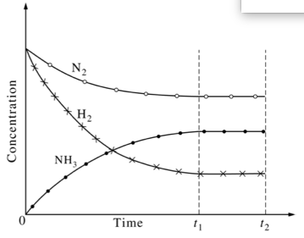
_____7) Which of the following was true for the system between t₁ and t₂?

(A) The concentration of N₂ decreased.
(B) The temperature for the system decreased.
(C) The number of effective collisions between H₂ gas and N₂ gas was zero
(D) The rate of the forward and reverse reactions were equal.
(E) The rate of formation of NH₃ molecules was equal to the rate of disappearance of H₂ molecules.

_____8) More NH₃ gas is added to the system at time t₂ while the temperature is held constant. Which of the following will most likely occur?

(A) The value of the equilibrium constant will increase.
(B) The value of the equilibrium constant will decrease
(C) The total pressure in the container will decrease
(D) The amount of N₂ will increase.
(E) The amount of H₂ will decrease.

_____9). In which reaction will the point of equilibrium shift to the left when the pressure on the system is increased?
(A) 2Mg(s) + O₂(g) ⇄ 2MgO(s)
(B) CaCO₃(s) ⇄ CaO(s) + CO₂(g)
(C) C(s) + O₂(g) ⇄ CO₂(g)
(D) 2H₂(g) + O₂(g) ⇄ 2H₂O(g)

Use the following information for questions 10-11
BaSO₄(s) ↔ Ba²⁺(aq) + SO₄²⁻(aq)
The questions below apply to an equilibrium system based on the reversible reaction given above.

_____10) What will happen to [Ba²⁺] if additional solid BaSO₄ is added to the flask?

(A) It will increase
(B) It will decrease
(C) It will not change
(D) Cannot tell with the information provided

_____11) Which direction will this reaction shift if water is added to the system above at equilibrium:

(A) The reaction shifts left because Q> K
(B) The reaction shifts right because Q<K
(C) The reaction does not shift because Q =K
(D) The reaction does not shift because water is a pure liquid

_____12) CH₃CH=CH₂(g) ↔ C₃H₆(g)
Le Chatelier's Principle predicts which action causes the endothermic reaction above to form more CH₃CH=CH₂ than initially present at equilibrium?

(A) Increasing the system temperature
(B) Decreasing the system temperature
(C) Increasing the system pressure
(D) Decreasing the system pressure

_____13) For the endothermic reaction: CaCO₃(s) ↔ CaO(s) + CO₂(g)
Only ______ would favor shifting the equilibrium position to form more CO₂ gas

(A) increasing the pressure
(B) decreasing the system temperature
(C) decreasing the pressure
(D) decreasing the volume

_____14) Which direction will this reaction shift if water is added to the system below at equilibrium: 4HCl(g) + O₂(g) ↔ 2H₂O(l) + 2Cl₂(g)

(A) The reaction shifts left because Q> K
(B) The reaction shifts right because Q<K
(C) The reaction does not shift because Q =K
(D) The reaction does not shift because water is a pure liquid

