AP Chemistry Unit 6 - Bonding - Hybridization Handout

Hybridization
- Mixing of atomic orbitals to make new “hybrid” orbitals of new energy and shape suitable for chemical bonding.
- Concept of mixing atomic orbitals into new hybrid orbital's (with different energies shapes, etc than original atomic orbitals)
- Useful in explaining molecular geometry

- Hybrid bonding
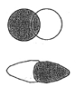
  - σ bond (sigma)
    - single bond
Single bond – sigma
Double bond – sigma, pi
Triple bond – sigma, pi, pi
    - free rotation characterized by head on overlap
    - also part of double and triple bonds
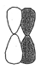
  - π bond
    - double/triple bonds
    - no rotation
    - can only with empty p orbitals

- To create 4 areas around a central atom you need to utilize 4 orbitals (think valence)
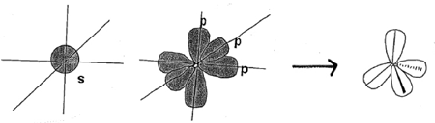
1 s orbital used 3 p orbitals used 4 sp³ orbitals

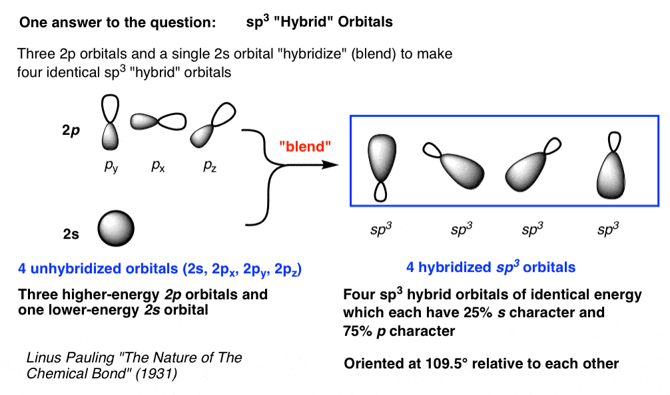
Example Carbon

4 σ Bonds
0 π Bonds
0 paired

hybridization

P
Energy

S + P + P + P = SP³
S

- Produces 4 singly occupied orbitals
- The energy released by the formation of 2 additional bonds more than compensates for the excitation energy required, energetically favoring the formation of 4 C-H bonds

- To create 3 areas around a central atom, you need to utilize 3 orbitals
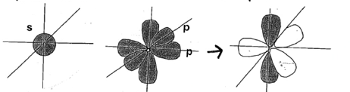
1 s orbital used 2 of 3 p’s orbitals 1 p orbital unchanged
3 sp² orbitals

Example SP² - using N

1 π Bonds

hybridization

P
P
Energy

2 σ Bonds
1 paired e

S + P + P = SP²
S

- To create 2 areas around a central atom, you need to utilize 2 orbitals
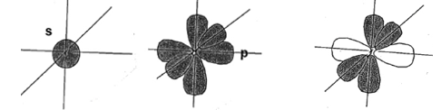
1 s orbital used 1 of 3 p’s orbitals 2 p orbitals unchanged
2 sp orbitals

Example SP - using C

2 π Bonds

hybridization

P
P
Energy

2 σ Bonds
0 paired e

S + P = SP
S

